Screen :-

It is very good for remote administration .

$ sudo apt-get install screen

When we need to execute / compile something for longer time ,
So what this is basically does that it open a terminal within terminal .

So new terminal is running inside server which is not affected by our ssh or putty terminal .

So just login into you server / putty session and type
$screen

Now all the command of screen start with “ctrl+A”

“^A” indicate ctrl

“ Ctrl+A” “?” we will get all our key binding .

Use “ctrl+A+D” to detach the screen’s terminal , and that terminal is still running inside the server/putty remote server.

$ screen -ls => this will tell you about your screen

$ screen -r will re attach you , what is in you before

$ ctrl+A+N => then you will see all the screen , you work on is still open .

$ screen -X -S “screen#” kill -> to kill screen

But doing detach and run anything , it will still run if you exit or close terminal

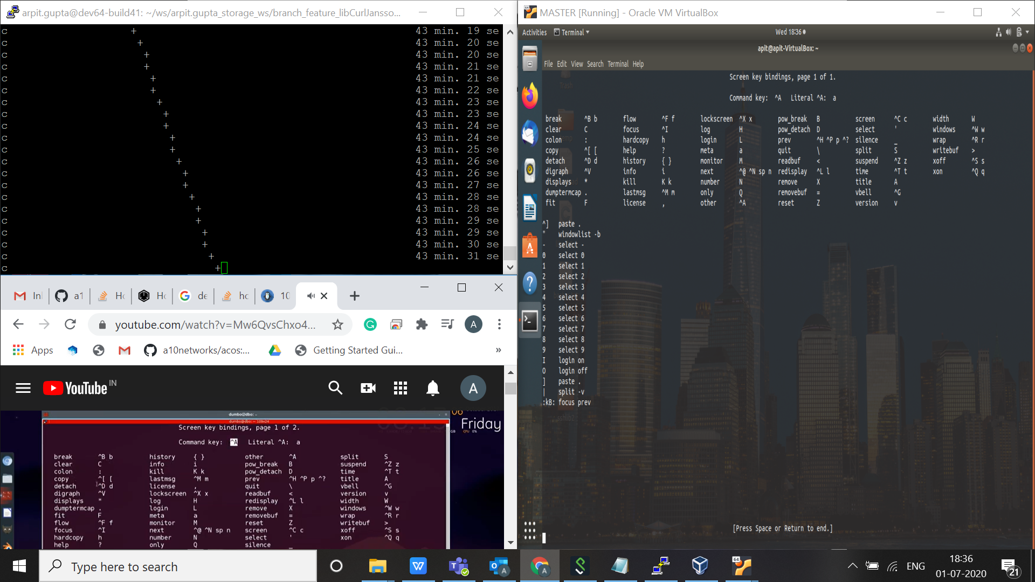

By doing “ctrl+A+?”

Ctrl+A + capital “S” will do split => crtl+A + Shift +s

Crtl+a + ctrl+c => this will create a new screen within a screen .

Ctrl+a + ctrl+n => swich to next screen

Ctrl+a + shift+| (pipe) => to split screen vertically

Ctrl+a + tab => to switch between same screen split section .

On same screen in different parts switch with (ctrl + a + tab ) and do (ctrl+a + ctrl+n) to start next session on that part .
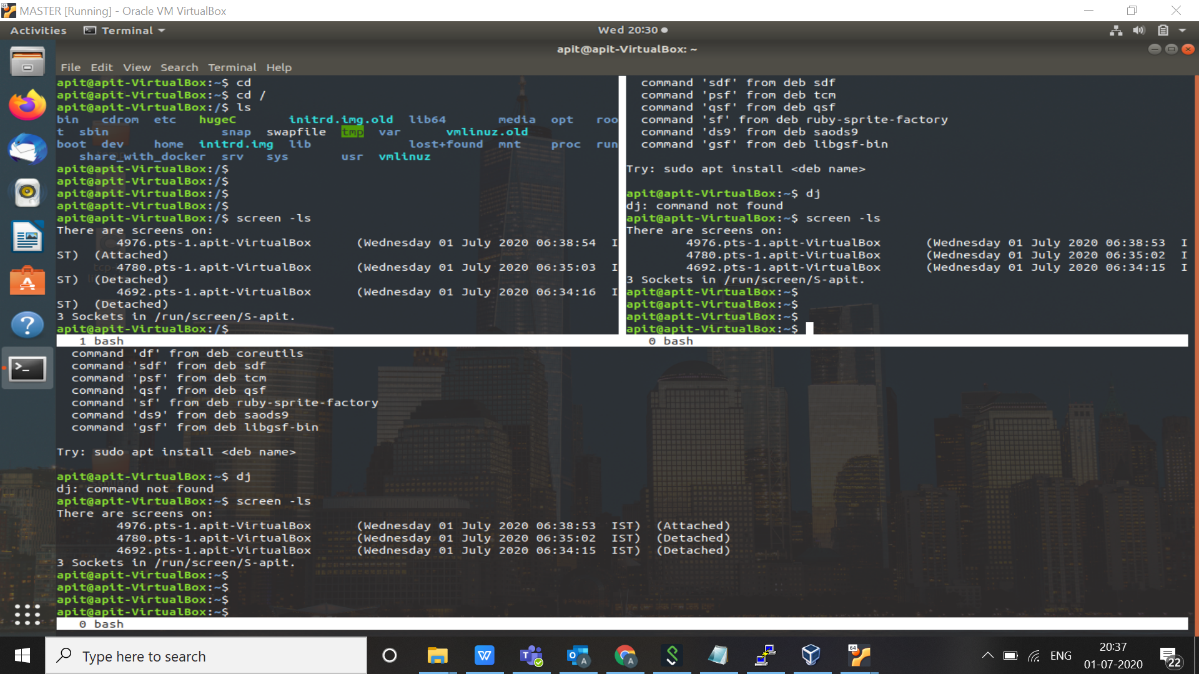

Like that

Now we are going to detach out terminal , now this detach will continue running on server whether our base terminal is on or off .

To detach use ( ctrl+a + ctrl+d )

